|  |  |
| --- | --- |
| DATE | 06-11-2022 |
| TEAM ID | PNT2022TMID16212 |
| PROJECT NAME | SMART SOLUTION FOR RAILWAYS |

CREATION OF NODE RED:

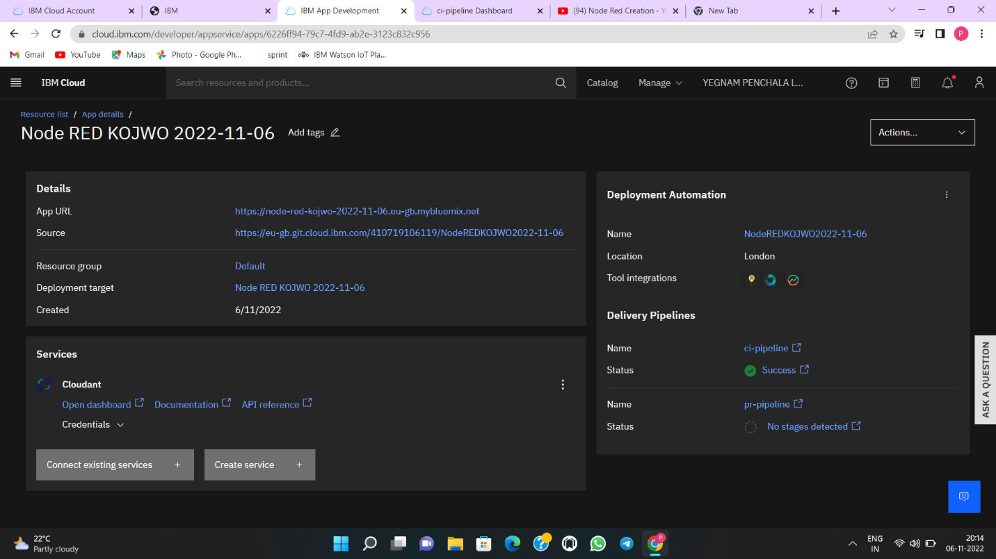

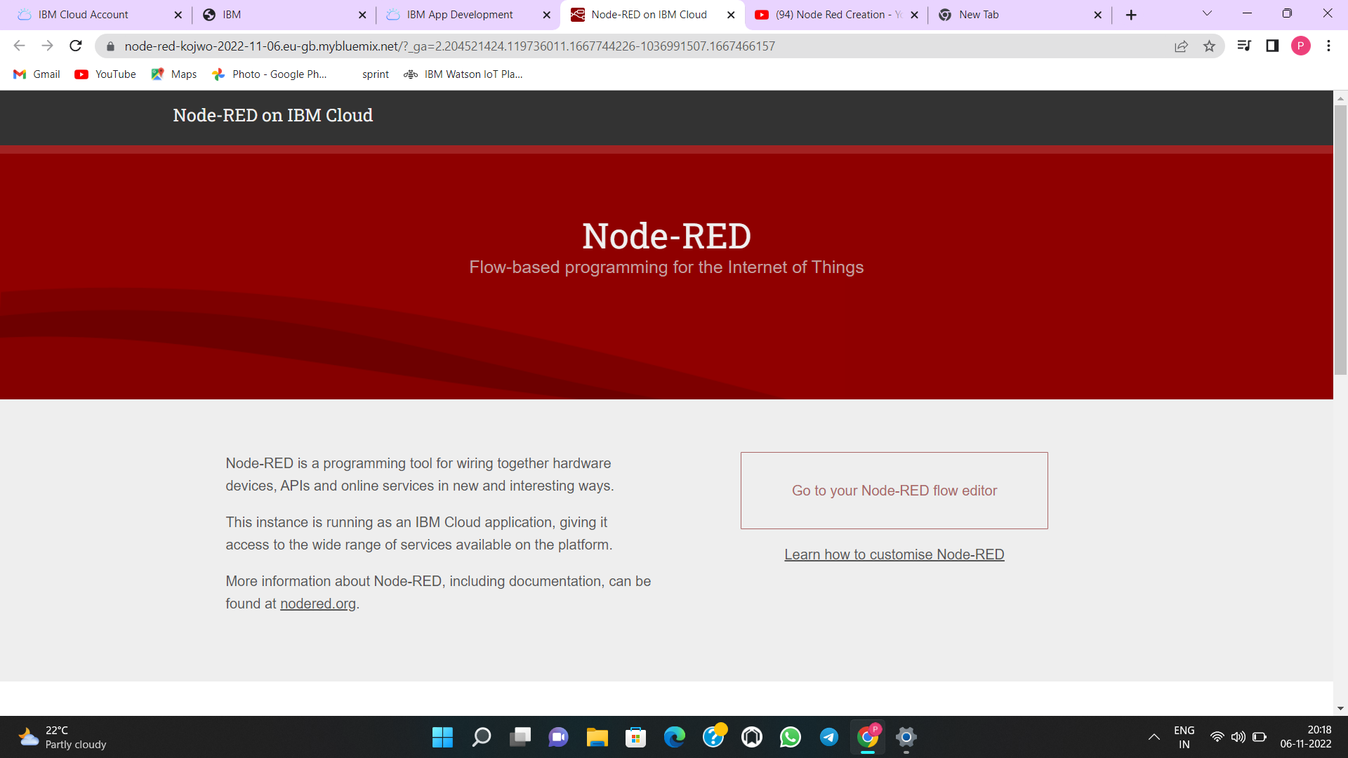

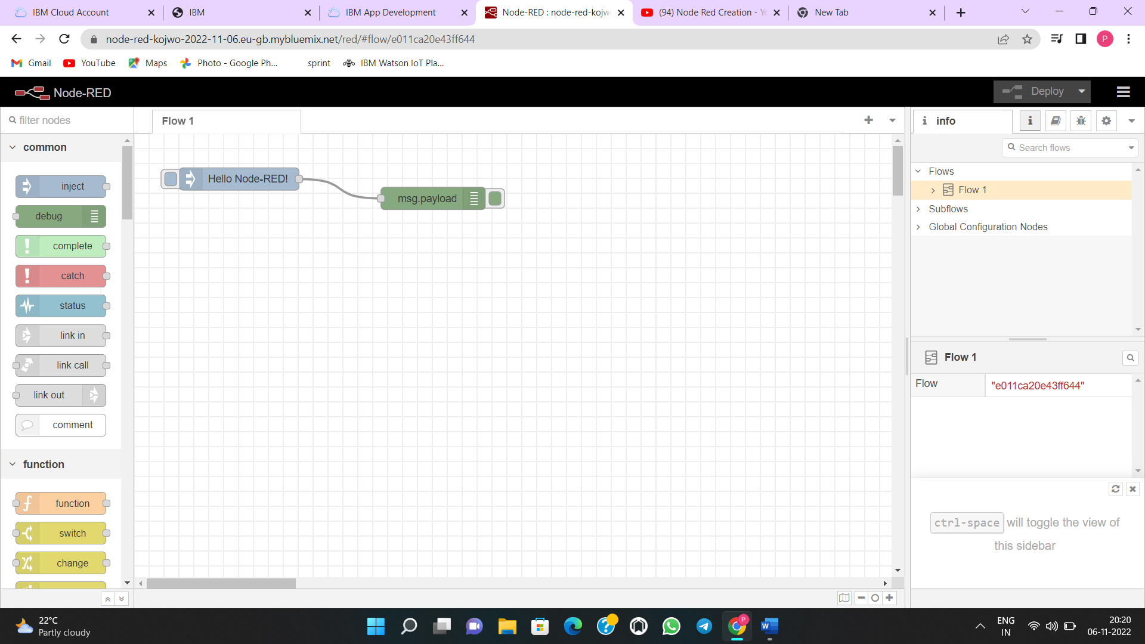

PASSENGER DATA:

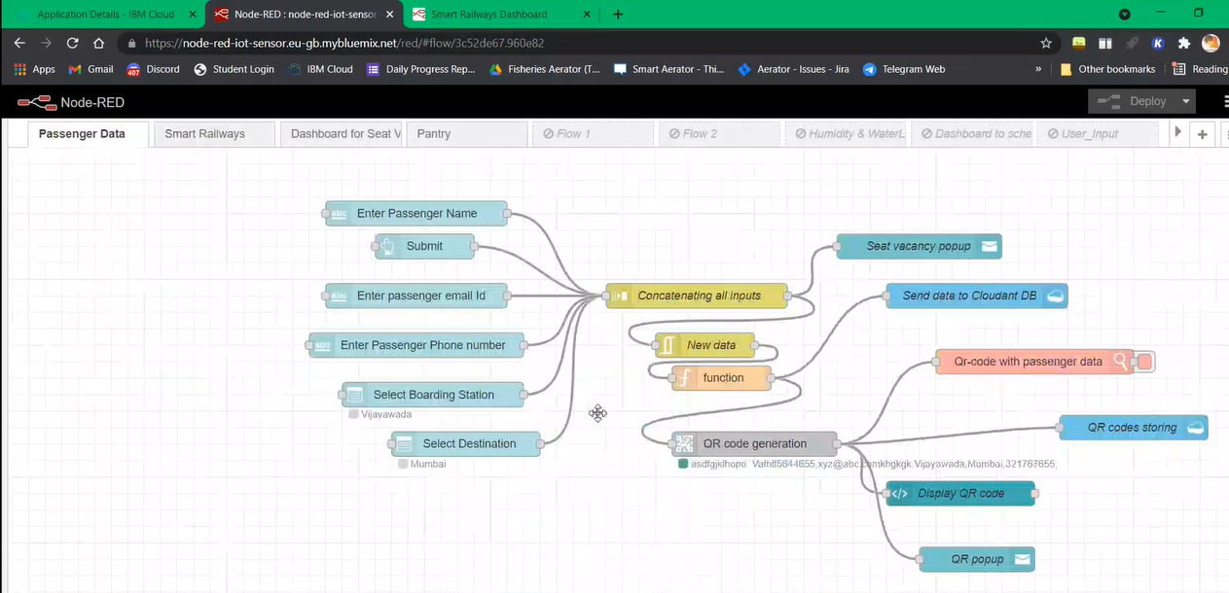

SMART RAILWAYS:

